Report for reg_file

1. Functional Simulation

The checking operations are described below:

1. Let rs, rt, rd <= “00000” -- point to reg(0)

2. Generate a random number and let wd <= number -- a random value to be written

3. Set we <= ‘1’ to perform write function -- write the random value into rd

4. Check if rd1 and rd2 are equal to wd -- check the values read from rs and rt

Then repeat 2-4 to generate 1000 random numbers in total to check if the read values are equal to the written values in all the 1000 cases.

After these 1000 case, let rs, rt and rd point to reg(1) (“00001”) and do another 1000 random cases, then reg(2), reg(3), …… until reg(30). (reg(31) is not used for write operation)

So there are totally 31*1000 = 31000 cases checked in this test bench. If anything goes wrong during the simulation, it will stop and report “Wrong”. If all cases pass, it will show that “1000*31 cases passed”.

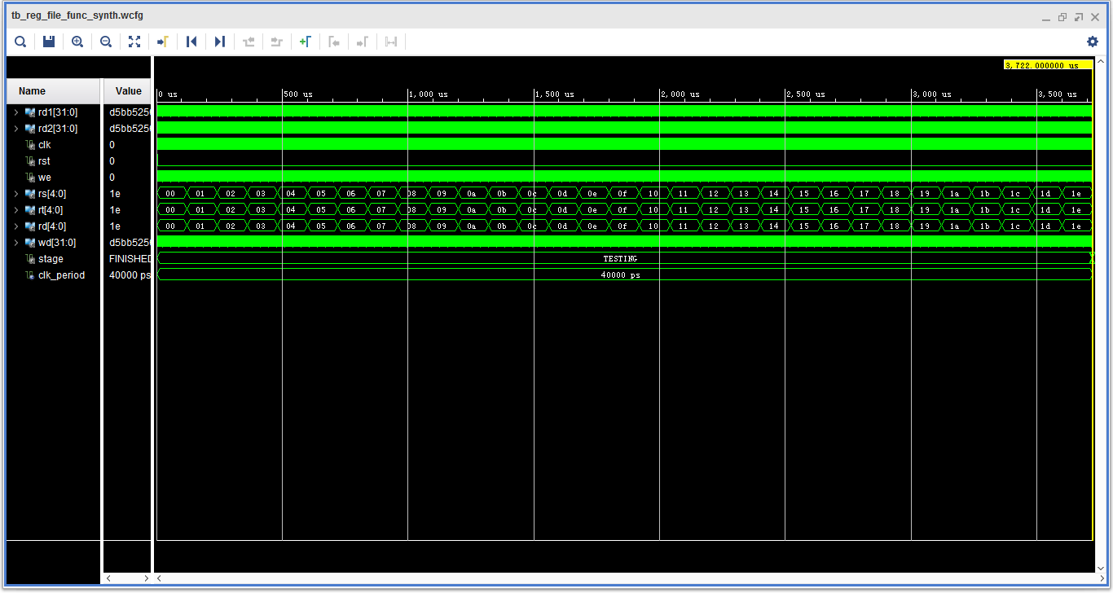

Figure 1. The whole simulation.

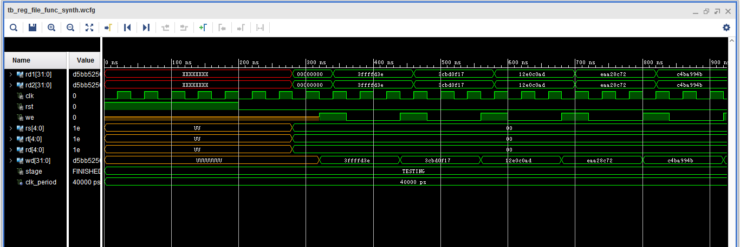

Figure 2. The first few cases

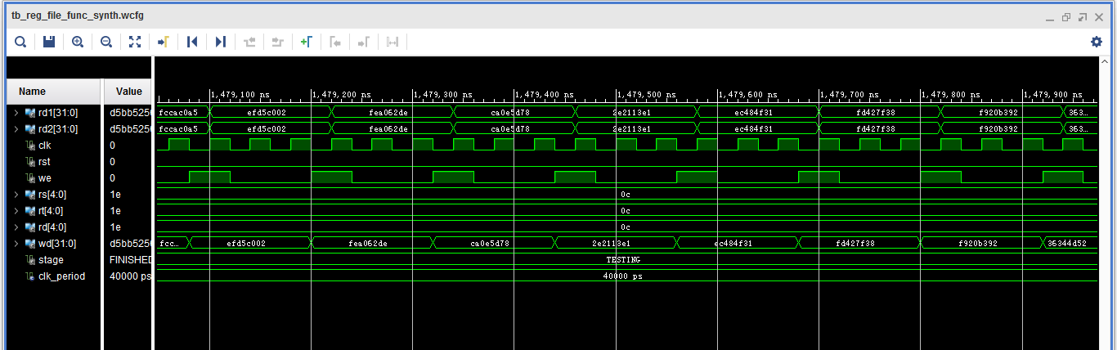

Figure 3. A few cases during the simulation

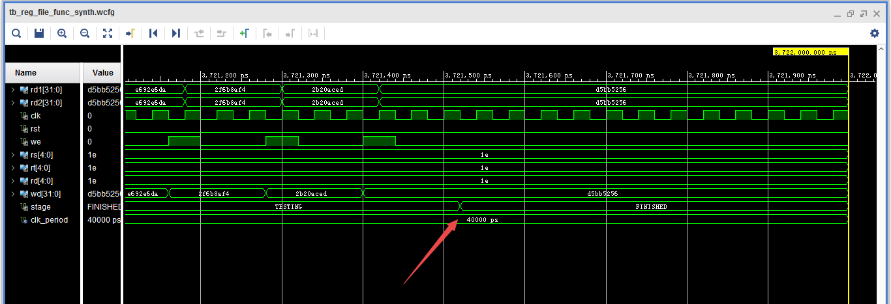

Figure 4. The last few cases.

Notice that after all the cases finished, the state will change from TESTING to FINISHED.

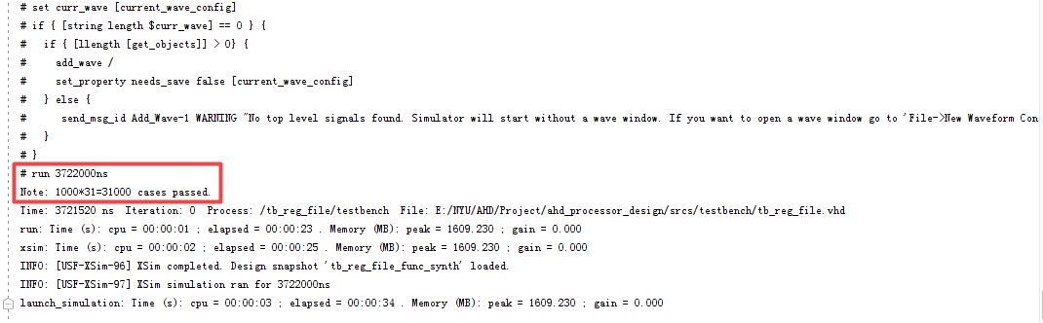

Figure 5. The report message after passing all the test cases.